**TOWSON UNIVERSITY**

**OFFICE OF GRADUATE STUDIES**

**(TITLE OF THESIS/DISSERTATION TYPED IN CAPITAL LETTERS)**

**(DOUBLE SPACED AND CENTERED)**

**(INVERSE PYRAMID)**

**by**

**(Student’s Name)**

**A dissertation**

**Presented to the faculty**

**of Towson University**

**in partial fulfillment**

**of the requirements for the degree**

**Doctor of Philosophy**

**Department of _______________ (1.5 spacing and centered)**

**Towson University,**

**Towson, Maryland**

**21252 (1.5 spacing and centered)**

**(Month, Year of Graduation)**

# Dissertation Approval Page

[Insert image of completed [**Thesis/Dissertation Approval Page Form**](https://www.towson.edu/academics/graduate/office/documents/finalthesisapprovalforms.pdf). Image should not overlap the lefthand margin.]

Acknowledgements

Your text here. Lorem ipsum dolor sit amet, consectetur adipiscing elit. Aliquam ac malesuada leo. Aliquam sit amet eros eleifend, molestie quam eu, scelerisque tortor. Etiam vel diam rutrum, maximus arcu nec, tempus magna. Praesent pretium, mauris eget euismod facilisis, libero lorem laoreet leo, at bibendum arcu massa at dui. Aliquam id felis mi. Vivamus egestas efficitur metus, sed semper libero facilisis in. Cras id scelerisque quam, sit amet dictum tellus. Integer porttitor laoreet iaculis. In hac habitasse platea dictumst. Nullam justo ante, lacinia in tristique sed, vehicula in purus. Phasellus condimentum dapibus mauris, id molestie tortor. Nullam vel ante nulla. Etiam aliquam varius sem, sit amet luctus massa rhoncus in. Praesent eget ex nec lacus tincidunt facilisis nec id ligula. Quisque sollicitudin, massa vitae laoreet aliquam, tortor lacus condimentum ligula, vitae sodales velit mauris ut magna. Duis eleifend vulputate ultricies.

Aliquam finibus, metus lobortis eleifend consequat, orci justo interdum felis, vitae blandit nisi ipsum vitae mi. Suspendisse vitae pulvinar justo. Nulla elementum eleifend nulla at finibus. Quisque molestie neque eget risus elementum, vel aliquam odio porttitor. Vivamus rhoncus pharetra leo, ut ultricies dolor. Curabitur vel lacinia diam, in laoreet justo. Duis scelerisque porta justo, quis lacinia nulla porta non. Proin ullamcorper enim at orci dignissim, et imperdiet metus ultrices. Nam interdum nulla tortor, viverra sollicitudin lectus convallis eu. Ut sed quam congue, ullamcorper nulla eget, mollis mauris. Vivamus sagittis quam leo, eu pulvinar enim eleifend a.

Abstract

YOUR TITLE HERE: USE THE SAME CAPITALIZATION,

PUNCTUATION, AND INVERSE PYRAMID

SPACING AS ON THE TITLE PAGE

Your Name Here

Your text here. Lorem ipsum dolor sit amet, consectetur adipiscing elit. Aliquam ac malesuada leo. Aliquam sit amet eros eleifend, molestie quam eu, scelerisque tortor. Etiam vel diam rutrum, maximus arcu nec, tempus magna. Praesent pretium, mauris eget euismod facilisis, libero lorem laoreet leo, at bibendum arcu massa at dui. Aliquam id felis mi. Vivamus egestas efficitur metus, sed semper libero facilisis in. Cras id scelerisque quam, sit amet dictum tellus. Integer porttitor laoreet iaculis. In hac habitasse platea dictumst. Nullam justo ante, lacinia in tristique sed, vehicula in purus. Phasellus condimentum dapibus mauris, id molestie tortor. Nullam vel ante nulla. Etiam aliquam varius sem, sit amet luctus massa rhoncus in. Praesent eget ex nec lacus tincidunt facilisis nec id ligula. Quisque sollicitudin, massa vitae laoreet aliquam, tortor lacus condimentum ligula, vitae sodales velit mauris ut magna. Duis eleifend vulputate ultricies.

**Table of Contents**

List of Tables vi

List of Figures vii

Keys to Symbols, Abbreviations, or Nomenclature viii

Chapter 1 How to Use This Template 1

Page Numbers 1

Required Pages 1

Paragraph Styles 1

Multi-Line Headings 2

Text That Continues on the Same Line as the Heading 2

Figure and Table Titles 3

Table of Contents, List of Tables, and List of Figures 3

Chapter 2 Chicago Style Headings 4

Chicago Style Heading Level 2 4

Chicago Style Heading Level 3 4

Chicago style heading level 4 5

Chicago style heading level 5. 5

Chapter 3 Chicago Style Headings with Numbering 6

3.1 Chicago Style Heading Level 2 6

3.1.1 Chicago Style Heading Level 3 6

3.1.1.1 Chicago style heading level 4 7

3.1.1.1.1 Chicago style heading level 5. 7

Chapter 4 Figures 8

Chapter 5 Tables 10

Chapter 6 Landscape Pages 12

Landscape page example 13

Appendix A Appendix Title 14

References 15

List of Tables

Table 1 . APA Style Table Title 10

Table 2. IEEE Style Table Heading 11

List of Figures

Figure 1. APA Style Figure Title 8

Figure 2. IEEE style figure caption. 9

Keys to Symbols, Abbreviations, or Nomenclature

[Optional - If used, the layout is up to the discretion of the student in consultation with the thesis/dissertation chairperson. The symbols, abbreviations, and nomenclature are to be consistent with those specified by the academic discipline and style manual.]

Chapter 1  
  
How to Use This Template

You can type or paste your thesis or dissertation directly into this template to easily meet the formatting requirements. Read the comments for notes and explanations.

Page Numbers

Page numbers in this document are pre-formatted according to the [Guidelines for Preparing Theses and Dissertations](https://www.towson.edu/academics/graduate/office/documents/2025guidelines.pdf). Simply add or delete pages from each section as needed. The final page is left intentionally blank with no page number.

Required Pages

Preliminary and supplementary pages are labeled in the order they should appear. Optional pages are marked as optional in the comments. List of Tables and List of Figures are required only when 2 or more tables/figures appear in the document.

Paragraph Styles

On the Home tab, under “Styles,” you will find pre-formatted headings for various heading levels and styles. Each heading is labelled based on the style and level. For instance, *IEEE 2* is a second-level heading in IEEE style. Pre-formatted styles are available for APA, IEEE, and Chicago styles. You may also create your own styles by selecting “Create a Style” from the dropdown menu. Do not mix headings from different styles. Use **Heading 1** for all page headings and chapter headings (except IEEE chapter headings).

Multi-Line Headings

Some headings, such as chapter headings, span multiple lines. If you create a line break by pressing ENTER, the heading will appear on the table of contents as two separate entries. Instead, press SHIFT+ENTER twice to skip a line without creating a second entry on the table of contents.

Text That Continues on the Same Line as the Heading

In some styles, text continues on the same line after a heading. For instance, in Chicago style, a 4th-level heading looks like this:

**-----**

**Heading.** Lorem ipsum dolor sit amet, consectetur adipiscing elit. Aliquam ac malesuada leo. Aliquam sit amet eros eleifend, molestie quam eu, scelerisque tortor. Etiam vel diam rutrum, maximus arcu nec, tempus magna.

**-----**

If you format the entire paragraph as a 5th-level heading, the entire text of the paragraph will appear on the table of contents. Instead, first format the heading as a separate paragraph, like so:

**-----**

**Heading.**

Lorem ipsum dolor sit amet, consectetur adipiscing elit. Aliquam ac malesuada leo. Aliquam sit amet eros eleifend, molestie quam eu, scelerisque tortor. Etiam vel diam rutrum, maximus arcu nec, tempus magna.

**-----**

Then, with your cursor to the right of the period, press CTRL+ALT+ENTER. The paragraph will appear on the same line as the heading, but will not appear on the table of contents.

Figure and Table Titles

Figure numbers and titles should be formatted using the “Figure Titles” style, and table numbers and titles should be formatted using the “Table Titles” style. This allows them to be pulled into the List of Figures and List of Tables automatically.

If the number and title should appear on separate lines within the document but should be one entry on the List of Tables/Figures, press SHIFT+ENTER instead of ENTER to skip a line. (Refer to Multi-Line Headings section above).

The “Figure Titles” and “Table Titles” styles will be flush left and bold automatically, but you can edit the formatting after selecting the heading style to match your chosen style.

Table of Contents, List of Tables, and List of Figures

A Table of Contents, List of Tables, and List of Figures are set up already. The Table of Contents will provide page numbers for all headings and format them based on the heading level. The List of Tables and List of Figures will pull the page numbers for the “Table Titles” and “Figure Titles” paragraph styles, respectively.

In order to update a table with new or changed headings, right-click in the table, then select “Update Field” – “Update entire table.” To update page numbers only, select “Update Field” – “Update page numbers only.”

Chapter 2  
  
Chicago Style Headings

This chapter uses [Chicago style headings](https://owl.purdue.edu/owl/research_and_citation/chicago_manual_17th_edition/cmos_formatting_and_style_guide/general_format.html). While The Chicago Manual of Style does not include a prescribed system for formatting headings and subheads, Turabian has an optional system of five heading levels, on which the headings in this chapter are based.

Chicago Style Heading Level 2

Lorem ipsum dolor sit amet, consectetur adipiscing elit. Aliquam ac malesuada leo. Aliquam sit amet eros eleifend, molestie quam eu, scelerisque tortor. Etiam vel diam rutrum, maximus arcu nec, tempus magna. Praesent pretium, mauris eget euismod facilisis, libero lorem laoreet leo, at bibendum arcu massa at dui. Aliquam id felis mi. Vivamus egestas efficitur metus, sed semper libero facilisis in. Cras id scelerisque quam, sit amet dictum tellus.

Chicago Style Heading Level 3

Lorem ipsum dolor sit amet, consectetur adipiscing elit. Aliquam ac malesuada leo. Aliquam sit amet eros eleifend, molestie quam eu, scelerisque tortor. Etiam vel diam rutrum, maximus arcu nec, tempus magna. Praesent pretium, mauris eget euismod facilisis, libero lorem laoreet leo, at bibendum arcu massa at dui. Aliquam id felis mi. Vivamus egestas efficitur metus, sed semper libero facilisis in. Cras id scelerisque quam, sit amet dictum tellus.

Chicago style heading level 4

Lorem ipsum dolor sit amet, consectetur adipiscing elit. Aliquam ac malesuada leo. Aliquam sit amet eros eleifend, molestie quam eu, scelerisque tortor. Etiam vel diam rutrum, maximus arcu nec, tempus magna. Praesent pretium, mauris eget euismod facilisis, libero lorem laoreet leo, at bibendum arcu massa at dui. Aliquam id felis mi. Vivamus egestas efficitur metus, sed semper libero facilisis in. Cras id scelerisque quam, sit amet dictum tellus.

Chicago style heading level 5.

Lorem ipsum dolor sit amet, consectetur adipiscing elit. Aliquam ac malesuada leo. Aliquam sit amet eros eleifend, molestie quam eu, scelerisque tortor. Etiam vel diam rutrum, maximus arcu nec, tempus magna. Praesent pretium, mauris eget euismod facilisis, libero lorem laoreet leo, at bibendum arcu massa at dui. Aliquam id felis mi. Vivamus egestas efficitur metus, sed semper libero facilisis in. Cras id scelerisque quam, sit amet dictum tellus.

Chapter 3  
  
Chicago Style Headings with Numbering

This chapter uses [Chicago style headings](https://owl.purdue.edu/owl/research_and_citation/chicago_manual_17th_edition/cmos_formatting_and_style_guide/general_format.html) with numbering. You will use the same heading styles with or without numbering, but this chapter is here to show you what the numbering should look like. While The Chicago Manual of Style does not include a prescribed system for formatting headings and subheads, Turabian has an optional system of five heading levels, on which the headings in this chapter are based.

3.1 Chicago Style Heading Level 2

Lorem ipsum dolor sit amet, consectetur adipiscing elit. Aliquam ac malesuada leo. Aliquam sit amet eros eleifend, molestie quam eu, scelerisque tortor. Etiam vel diam rutrum, maximus arcu nec, tempus magna. Praesent pretium, mauris eget euismod facilisis, libero lorem laoreet leo, at bibendum arcu massa at dui. Aliquam id felis mi. Vivamus egestas efficitur metus, sed semper libero facilisis in. Cras id scelerisque quam, sit amet dictum tellus.

3.1.1 Chicago Style Heading Level 3

Lorem ipsum dolor sit amet, consectetur adipiscing elit. Aliquam ac malesuada leo. Aliquam sit amet eros eleifend, molestie quam eu, scelerisque tortor. Etiam vel diam rutrum, maximus arcu nec, tempus magna. Praesent pretium, mauris eget euismod facilisis, libero lorem laoreet leo, at bibendum arcu massa at dui. Aliquam id felis mi. Vivamus egestas efficitur metus, sed semper libero facilisis in. Cras id scelerisque quam, sit amet dictum tellus.

3.1.1.1 Chicago style heading level 4

Lorem ipsum dolor sit amet, consectetur adipiscing elit. Aliquam ac malesuada leo. Aliquam sit amet eros eleifend, molestie quam eu, scelerisque tortor. Etiam vel diam rutrum, maximus arcu nec, tempus magna. Praesent pretium, mauris eget euismod facilisis, libero lorem laoreet leo, at bibendum arcu massa at dui. Aliquam id felis mi. Vivamus egestas efficitur metus, sed semper libero facilisis in. Cras id scelerisque quam, sit amet dictum tellus.

3.1.1.1.1 Chicago style heading level 5.

Lorem ipsum dolor sit amet, consectetur adipiscing elit. Aliquam ac malesuada leo. Aliquam sit amet eros eleifend, molestie quam eu, scelerisque tortor. Etiam vel diam rutrum, maximus arcu nec, tempus magna. Praesent pretium, mauris eget euismod facilisis, libero lorem laoreet leo, at bibendum arcu massa at dui. Aliquam id felis mi. Vivamus egestas efficitur metus, sed semper libero facilisis in. Cras id scelerisque quam, sit amet dictum tellus.

# Chapter 4 Figures

Figure 1.   
*APA Style Figure Title*

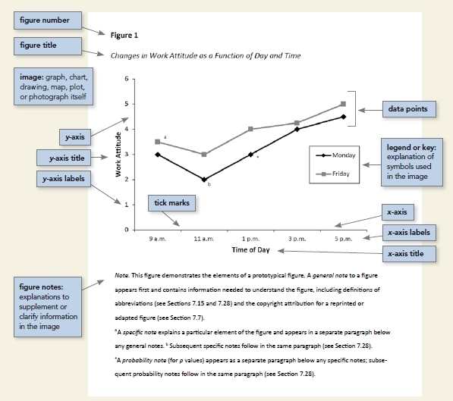

*Note*. Figure notes appear here. Lorem ipsum dolor sit amet, consectetur adipiscing elit. Aliquam ac malesuada leo. Aliquam sit amet eros eleifend, molestie quam eu, scelerisque tortor. Etiam vel diam rutrum, maximus arcu nec, tempus magna.

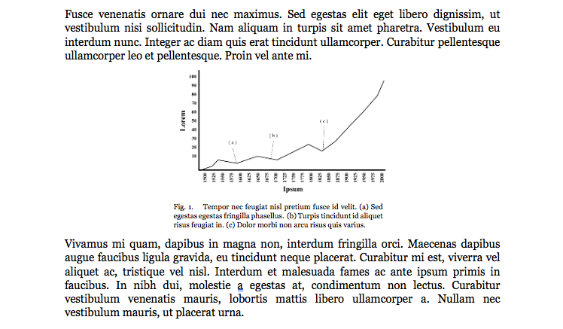

Fig. 2. IEEE style figure caption.

Lorem ipsum dolor sit amet, consectetur adipiscing elit. Aliquam ac malesuada leo. Aliquam sit amet eros eleifend, molestie quam eu, scelerisque tortor.

# Chapter 5 Tables

Table 1   
*APA Style Table Title*

|  |  |  |  |  |
| --- | --- | --- | --- | --- |
| Stub Heading | Column Spanner | | Column Spanner | |
|  | Column Heading | Column Heading | Column Heading | Column Heading |
| Table Spanner | | | | |
| Row 1 | 123 | 234a | 456 | 789 |
| Row 2 | 123 | 987 | 543 | 876 |
| Table Spanner | | | | |
| Row 3 | 432 | 567 | 543 | 908 |
| Row 4 | 256 | 849 | 407* | 385 |

*Note*. This is a general note, referring to information about the entire table. Notes should be double spaced.

aSpecific notes appear in a new paragraph; further specific notes follow in the same paragraph.

*A probability note appears in a new paragraph.

|  |  |  |
| --- | --- | --- |
| Table II IEEE Style Table Heading | | |
| Column 1 | Column 2 | Column 3 |
| Abcde | 123 | 1234 |
| Fghijk | 324 | 216* |
| Lmnop | 325 | 0 |
| Qrstuv | 9578 | 33 |

Below the table, you may include explanatory notes as necessary.

*Notes that apply to a specific part of the table should be marked in the same manner as a footnote.

# Chapter 6 Landscape Pages

Some tables and figures may fit better on a landscape-oriented page. When using a landscape page, the page numbers must be rotated so that they will appear in the correct orientation when the document is printed and bound. The following page is an example of a correctly numbered landscape page.

Landscape page example

# Appendix A Appendix Title

[Appendices follow the last page of the text. Each appendix should be labeled, either at the top or on a proceeding blank page, as Appendix A, Appendix B, etc. The sequence of the appendices follows the order in which they were first introduced in the main body of the text. Each appendix needs to be labeled and named in the main body of the text for it to be included in the appendix section.]

# References

[Depending on the style you’re using, the label at the top may be References, List of References, Citations, List of Sources, Bibliography, etc. [Specifications for Chicago style can be found here.](https://owl.purdue.edu/owl/research_and_citation/chicago_manual_17th_edition/cmos_formatting_and_style_guide/general_format.html) Since nearly all theses and dissertations make use of other works, either in direct quotation or by reference, this section typically is required. The format/style used is to conform to the requirements of the student’s academic discipline or the journal, monograph, book or other type of publication where the student intends to publish the work. Each citation listed in the text must be included in the bibliography. The minimum requirements usually are that the referencing system and bibliography be consistent throughout the manuscript, that they are clear, and that they fully agree with each other. All works cited in the text must be included in the bibliography. Some word processing systems provide features that assist with formatting citations and references.]